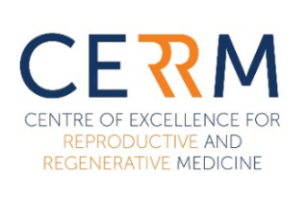
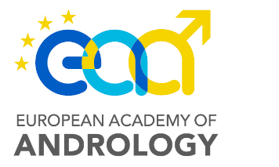
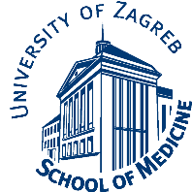

EAA SUMMER SCHOOL
Testis Histology and Pathology for Clinical Andrologists and Embryologists
preliminary dates 27 June - 1 July 2022
University of Zagreb School of Medicine, Šalata 3, Zagreb, Croatia
co-organized together with the ANDRONET COST action CA20119

APPLICATION FORM

PERSONAL DETAILS
Title | Title
First Name | First Name
Middle Name | Middle Name
Last Name | Last Name
Phone | Phone
E-mail | E-mail
Affiliation | Institution
 | Address line 1
 | Address line 2

PARTICIPANT CATEGORY
Choose a category

ACCOMMODATION
Choose an option

EAA TRAVEL GRANT
There are 5 EAA travel grants (350€ each) available for residents at EAA Centres. If you are eligible, please indicate below if you wish to apply for the grant.
Choose an option

☐ I hereby consent that the organizers use my personal data, official images and/or video recordings, for the registration, credit allocation and promotional/dissemination purposes.

The payment details as well as the EAA travel grant results shall be announced upon the selection of the participants.

Please, send the filled-out form, CV and list of publications to Ms. Jasna Turković at jasna.turkovic@mef.hr by 15 March 2022.

